**Privacy Policy** :

We will be adding Privacy policy + Terms & conditions as links in lead form

Below is the flow :   
  
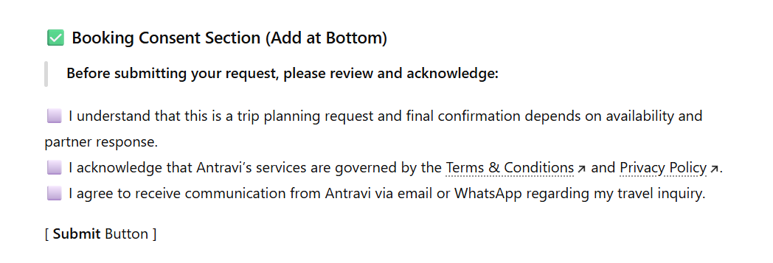

At **Antravi**, your privacy is not just a formality — it's the foundation of the trust we build with every journey. Whether you're exploring our site, planning your next getaway, or confirming a booking, we handle your personal information with the discretion and care you'd expect from a luxury travel curator.

**1. Information We Collect**

When you interact with Antravi, we may collect the following information:

* Full name
* Contact details (email address, phone number)
* Travel preferences and requirements
* Booking details (dates, destinations, accommodation choices, etc.)
* Payment and billing information

We only collect the information necessary to deliver a seamless and personalized travel experience.

**2. How We Use Your Information**

Your information is used to:

* Personalize your travel itinerary
* Coordinate with trusted partners (hotels, airlines, transport providers, etc.)
* Communicate updates and confirmations about your bookings
* Improve your overall experience with Antravi

We do **not** sell, rent, or misuse your data under any circumstances.

**3. Cookies & Tracking Technologies**

To improve your browsing experience, Antravi uses cookies and similar technologies to:

* Understand your preferences
* Show you relevant suggestions and content
* Analyze site performance

You may modify your browser settings at any time to manage or disable cookies.

**4. Sharing Your Information**

We may share necessary information with our trusted partners to fulfill your chosen travel services. This may include:

* Hotels and resorts
* Airlines and transportation providers
* Local tour operators and service providers
* Payment gateways

All partners are contractually obligated to protect your data and use it solely to deliver your requested services.

**5. Data Security**

We implement strong security measures to protect your personal information against unauthorized access, disclosure, or misuse. Your data is stored on secure systems and is accessed only by authorized personnel when required.

**7. Changes to This Policy**

We may update this Privacy Policy from time to time to reflect changes in regulations or our services. We encourage you to review this page periodically for the latest version.

**Antravi is committed to protecting your privacy — always.**  
We collect only what’s necessary to craft unforgettable travel experiences, and we treat your data with the same care and respect we give to every journey we plan.

Terms and conditions :

Welcome to **Antravi**. By accessing our website, browsing our services, or making a booking with us, you agree to the following Terms & Conditions. These terms are designed to protect you—our valued guest—and ensure transparency and trust in all our interactions. We encourage you to read them carefully before confirming your travel arrangements.

**A. Our Services**

Antravi is a premium boutique travel consultancy specializing in personalized journeys. We curate exceptional travel experiences by coordinating with carefully selected hotels, resorts, transportation providers, and local partners.

We act solely as a facilitator and intermediary. While we strive to ensure the highest quality of service, the actual execution of travel components (e.g., accommodation, transfers, activities) is the responsibility of our partners.

B. **Booking & Confirmation**

* A booking is considered confirmed only after receipt of full or partial payment, as specified in your selected package.
* Upon confirmation, you will receive a detailed itinerary via email.
* It is your responsibility to review all details carefully and notify us immediately of any discrepancies.

**C. Payments**

* Payments can be made through secure online gateways, bank transfers, or other accepted methods specified by Antravi.
* All prices are quoted in **Indian Rupees (INR)** unless stated otherwise and are subject to change based on availability and partner pricing.
* Any applicable bank charges, currency conversion fees, or international transaction costs are the responsibility of the client.

D. **Cancellations & Refunds**

We understand that travel plans can change. Our cancellation and refund policies are as follows:

* Cancellation terms vary depending on the specific service providers (e.g., hotels, airlines, tour operators).
* The applicable cancellation policy will be clearly communicated at the time of booking.
* Refunds, if eligible, will be processed in accordance with the partner’s policy and may take up to **30 business days**.
* Some bookings may be **non-refundable or partially refundable**, depending on the type of services availed.

E. **Responsibilities & Limitations**

Antravi is not liable for delays, disruptions, or cancellations caused by events beyond our control, including but not limited to natural disasters, political unrest, strikes, pandemics, or severe weather. You are solely responsible for ensuring you possess valid travel documents (passports, visas, health certificates, etc.). While we can guide you, we are not liable for any denials, delays, or issues arising from documentation. Travel involves inherent risks. Antravi is not responsible for any injury, loss, damage, or inconvenience experienced during your journey.

F. **Guest Conduct**

We expect all guests to maintain respectful and responsible behavior toward service providers, staff, and local communities.  
Any misconduct may result in the termination of services without refund or compensation.

G. **Intellectual Property**

All content on the Antravi website and marketing platforms—including logos, designs, images, text, and brand elements—is the exclusive property of **Antravi** and protected under intellectual property laws.

Use, reproduction, or distribution of any content without prior written consent is strictly prohibited.

H. **Changes to These Terms**

Antravi reserves the right to update or modify these Terms & Conditions at any time.  
Any changes will take effect immediately upon being published on our website.  
We recommend reviewing this page periodically to stay informed.

I **Governing Law**

These Terms & Conditions are governed by the laws of **India**, and any disputes will fall under the jurisdiction of the courts in **Hyderabad, Telangana**.

**At Antravi, we believe that every journey should be effortless, elegant, and entirely yours.**  
These terms ensure we can focus on what matters most: crafting unforgettable travel moments, together.

You can cancel your booking anytime up to **31 days before your departure date (until 11:59 PM IST)** for a full refund. Cancellations made within 31 days of departure are non-refundable. However, if needed, you may reschedule your trip to new dates within 100 days of your original booking, subject to availability and additional charges. Please note that this cancellation policy may be updated or changed without prior notice.